**PROJECT DOCUMENTATION & SUBMISSION**

**WATER QUALITY ANALYSIS**

|  |  |
| --- | --- |
| **Date** | **29-10-2023** |
| **Team ID** | **1278** |
| **Project Name** | **Water Quality Analysis** |

**TABLE OF CONTENT PAGE.NO**

|  |  |  |
| --- | --- | --- |
| 1. | Introduction | 2 |
| 2. | Problem Statement and Objective | 3 |
| 3. | Design Thinking | 4 |
| 4. | Analysis Objective | 5 |
| 5. | Exploratory Data Analysis (EDA) | 5 |
| 6. | Data Preprocessing | 6 |
| 6.1. | Handling Of Missing Values | 9 |
| 7. | Data Visualization | 12 |
| 7.1. | Histogram & Distribution. | 12 |
| 7.2. | Boxplot | 13 |
| 7.3. | Scatter Plots. | 18 |
| 7.4. | Correlation Heatmap. | 19 |
| 8. | Predictive Modelling for Potability | 20 |
| 8.1. | Data Splitting. | 21 |
| 8.2. | Predictive Model. | 21 |
| 8.3. | **Hyperparameter tuning the RandomForest model.** | 22 |
| 8.4. | **RandomForest model Accuracy Score.** | 22 |
| 8.5. | **Confusion Matrix** | 23 |
| 9. | Analysis Insights | 23 |
| 10. | FINAL IBM COGNOS REPORT: | 24 |
| 11. | Conclusion | 25 |

**1.Introduction:**

Access to clean, safe drinking water stands as a cornerstone of human well-being, impacting health, sanitation, and overall quality of life. In today's data-driven world, the analysis of water quality data has become indispensable, forming the basis for informed decision-making and public health initiatives. This project embarks on a vital exploration, delving deep into the intricate realm of water quality assessment. The dataset under scrutiny contains a plethora of parameters, ranging from pH, hardness, solids, chloramines, sulfate, conductivity, organic carbon, trihalomethanes, to turbidity. Each of these factors holds a key to understanding the purity and safety of water for consumption, making this analysis a significant endeavor.

At its core, this project is driven by a fundamental objective: to ensure that water, a fundamental human necessity, meets the stringent standards required for consumption. Clean water is not merely a privilege; it is a right, essential for the very survival of communities and societies. Beyond its elemental importance, water quality also directly impacts public health. Contaminated water sources can lead to a myriad of waterborne diseases, posing severe threats to communities, especially in regions where resources are scarce. In this context, the rigorous analysis of water quality data emerges as a crucial endeavor, aligning with global goals outlined in sustainable development agendas to provide universal access to safe and affordable drinking water.

The multifaceted nature of this project is underscored by its diverse objectives. Firstly, it entails a comprehensive analysis of the provided dataset. Through advanced statistical methods, this analysis aims to unravel the intricate patterns embedded within the data. By identifying correlations and deviations from established standards, the project seeks to paint a vivid picture of the water quality landscape. This understanding is not merely theoretical; it translates into tangible, real-world implications. It empowers policymakers, environmentalists, and communities alike with the knowledge necessary to advocate for and enforce water quality regulations, ensuring that the water supplied to households is devoid of harmful contaminants.

In tandem with this analysis, the project ventures into the realm of predictive modeling. By employing sophisticated machine learning techniques like the Random Forest Classifier, the analysis goes beyond mere observation, diving into the realm of anticipation. Predictive modeling serves as a proactive tool, enabling the identification of potential water quality issues before they escalate. Moreover, the integration of methods like Synthetic Minority Over-sampling Technique (SMOTE) showcases the project's commitment to addressing inherent challenges in the dataset, such as class imbalances. This not only enhances the accuracy of predictions but also underscores the project's commitment to robust, nuanced analyses

Innovation in data visualization is another cornerstone of this project. Traditional data analysis methods are often perceived as dense and esoteric. However, the project shatters this stereotype by harnessing innovative visualization techniques. Through the artful presentation of data using histograms, boxplots, scatter plots, and correlation heatmaps, the analysis is not confined to the realm of experts. It becomes accessible, comprehensible, and relatable to the average citize. These visualizations are not just aesthetically pleasing; they are informative, serving as educational tools that bridge the gap between complex data and public understanding.

Beyond the technical aspects, this project holds immense societal significance. It is a beacon of awareness, shining light on the critical issue of water quality. By distilling complex data into actionable insights, it empowers communities to make informed choices. In a world where climate change and pollution threaten the very resources we depend on, this project stands as a testament to the potential of data-driven solutions. It is a testament to human ingenuity and innovation, showcasing how technology can be harnessed not just for scientific advancement but for the betterment of society as a whole. As the project unfolds, it embodies the spirit of progress, the essence of knowledge, and the promise of a safer, healthier future for all.

**2.** **Problem Statement**

**Definition:**The project involves analyzing water quality data to assess the suitability of water for specific purposes, such as drinking. The objective is to identify potential issues or deviations from regulatory standards and determine water potability based on various parameters. This project includes defining analysis objectives, collecting water quality data, designing relevant visualizations, and building a predictive model. 

**Data**: We have a dataset containing key water quality parameters such as pH, Hardness, Solids, Chloramines, Sulfate, Conductivity, Organic_carbon, Trihalomethanes, Turbidity, and Potability.

**Objective**

* To provide an in-depth analysis of the design and innovation strategies for the analysing water quality data to assess the suitability of water for specific purposes, such as drinking.
* Access to clean and safe drinking water is a fundamental necessity for human well-being.
* It is essential for maintaining public health and preventing waterborne diseases.

**3.Design Thinking**

**Analysis Objectives:**

The primary objectives of this water quality analysis are to assess water potability, identify deviations from established standards, and understand the relationships among different parameters. By achieving these goals, we aim to provide valuable insights into the quality of the provided water dataset.

**Data Collection:**

The analysis utilizes the provided water quality data, encompassing essential parameters such as pH, Hardness, Solids, Chloramines, Sulfate, Conductivity, Organic Carbon, Trihalomethanes, and Turbidity. This dataset forms the foundation for our analysis and modeling.

**Visualization Strategy:**

The visualization strategy involves employing various tools to effectively communicate the data insights. Histograms, box plots, and scatter plots are utilized to visualize parameter distributions and identify outliers. Additionally, a correlation heatmap is generated to understand the relationships among different parameters. These visualizations are crucial for gaining a comprehensive understanding of the dataset's characteristics and deviations.

**Predictive Modeling:**

For predictive modeling, machine learning algorithms are employed to forecast water potability based on the provided parameters. The selected algorithm for this analysis is the Random Forest Classifier. Features such as pH, Hardness, Solids, Chloramines, Sulfate, Conductivity, Organic Carbon, Trihalomethanes, and Turbidity are used as input variables for the predictive model. The choice of features and the algorithm is vital for accurate predictions and is based on their relevance to water quality standards.

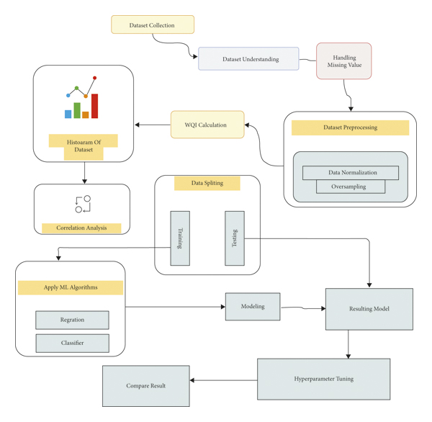

**4.Analysis Objectives:**

* The primary objective of this water quality analysis is to assess the potability of water based on various water quality parameters.
* The analysis aims to develop a predictive model that can accurately determine whether a given sample of water is potable or not.
* This determination is crucial for ensuring the safety and quality of drinking water supplied to consumers.

**5.Exploratory Data Analysis (EDA)**

* Exploratory Data Analysis was performed through various visualizations.
* Histograms were used to understand the distribution of different water quality parameters, helping identify patterns and potential outliers.
* Boxplots provided insights into the spread and presence of outliers in the numerical features.
* Scatter plots and pair plots were utilized to visualize relationships between different variables, especially concerning potability.
* A correlation heatmap was generated to understand the interdependencies among the features.

**6. Data Preprocessing**

* In the data preprocessing phase, missing values in the dataset were handled by filling them with the mean values of their respective columns.
* Outliers were detected using the Interquartile Range (IQR) method, and numerical features were scaled for modelling.
* Additionally, the data was balanced using the Synthetic Minority Over-sampling Technique (SMOTE) to handle class imbalance, ensuring a more robust predictive model.

# IMPORT SECTION

In [19]:

import numpy as np

import pandas as pd

import seaborn as sns

import matplotlib.pyplot as plt

import plotly.express as px

import missingno as msno

from sklearn.tree import DecisionTreeClassifier

from sklearn.ensemble import RandomForestClassifier

from sklearn.neighbors import KNeighborsClassifier

from sklearn.svm import SVC

from sklearn.model_selection import RandomizedSearchCV, RepeatedStratifiedKFold, train_test_split

from sklearn.metrics import precision_score, confusion_matrix

from sklearn import tree

from sklearn.model_selection import train_test_split, GridSearchCV

from sklearn.ensemble import RandomForestClassifier

from sklearn.metrics import accuracy_score, confusion_matrix

from sklearn.model_selection import cross_val_score

from sklearn.metrics import make_scorer

from imblearn.over_sampling import SMOTE

from sklearn.pipeline import Pipeline, make_pipeline

# DATASET

In [20]:

*#Displaying the dataset file.*

data = pd.read_csv("water_potability.csv")

data

Out[20]:

|  | **ph** | **Hardness** | **Solids** | **Chloramines** | **Sulfate** | **Conductivity** | **Organic_carbon** | **Trihalomethanes** | **Turbidity** | **Potability** |
| --- | --- | --- | --- | --- | --- | --- | --- | --- | --- | --- |
| **0** | NaN | 204.890455 | 20791.318981 | 7.300212 | 368.516441 | 564.308654 | 10.379783 | 86.990970 | 2.963135 | 0 |
| **1** | 3.716080 | 129.422921 | 18630.057858 | 6.635246 | NaN | 592.885359 | 15.180013 | 56.329076 | 4.500656 | 0 |
| **2** | 8.099124 | 224.236259 | 19909.541732 | 9.275884 | NaN | 418.606213 | 16.868637 | 66.420093 | 3.055934 | 0 |
| **3** | 8.316766 | 214.373394 | 22018.417441 | 8.059332 | 356.886136 | 363.266516 | 18.436524 | 100.341674 | 4.628771 | 0 |
| **4** | 9.092223 | 181.101509 | 17978.986339 | 6.546600 | 310.135738 | 398.410813 | 11.558279 | 31.997993 | 4.075075 | 0 |
| **...** | ... | ... | ... | ... | ... | ... | ... | ... | ... | ... |
| **3271** | 4.668102 | 193.681735 | 47580.991603 | 7.166639 | 359.948574 | 526.424171 | 13.894419 | 66.687695 | 4.435821 | 1 |
| **3272** | 7.808856 | 193.553212 | 17329.802160 | 8.061362 | NaN | 392.449580 | 19.903225 | NaN | 2.798243 | 1 |
| **3273** | 9.419510 | 175.762646 | 33155.578218 | 7.350233 | NaN | 432.044783 | 11.039070 | 69.845400 | 3.298875 | 1 |
| **3274** | 5.126763 | 230.603758 | 11983.869376 | 6.303357 | NaN | 402.883113 | 11.168946 | 77.488213 | 4.708658 | 1 |
| **3275** | 7.874671 | 195.102299 | 17404.177061 | 7.509306 | NaN | 327.459760 | 16.140368 | 78.698446 | 2.309149 | 1 |

3276 rows × 10 columns

In [21]:

*#Describing the dataset.*

data.describe()

Out[21]:

|  | **ph** | **Hardness** | **Solids** | **Chloramines** | **Sulfate** | **Conductivity** | **Organic_carbon** | **Trihalomethanes** | **Turbidity** | **Potability** |
| --- | --- | --- | --- | --- | --- | --- | --- | --- | --- | --- |
| **count** | 2785.000000 | 3276.000000 | 3276.000000 | 3276.000000 | 2495.000000 | 3276.000000 | 3276.000000 | 3114.000000 | 3276.000000 | 3276.000000 |
| **mean** | 7.080795 | 196.369496 | 22014.092526 | 7.122277 | 333.775777 | 426.205111 | 14.284970 | 66.396293 | 3.966786 | 0.390110 |
| **std** | 1.594320 | 32.879761 | 8768.570828 | 1.583085 | 41.416840 | 80.824064 | 3.308162 | 16.175008 | 0.780382 | 0.487849 |
| **min** | 0.000000 | 47.432000 | 320.942611 | 0.352000 | 129.000000 | 181.483754 | 2.200000 | 0.738000 | 1.450000 | 0.000000 |
| **25%** | 6.093092 | 176.850538 | 15666.690297 | 6.127421 | 307.699498 | 365.734414 | 12.065801 | 55.844536 | 3.439711 | 0.000000 |
| **50%** | 7.036752 | 196.967627 | 20927.833607 | 7.130299 | 333.073546 | 421.884968 | 14.218338 | 66.622485 | 3.955028 | 0.000000 |
| **75%** | 8.062066 | 216.667456 | 27332.762127 | 8.114887 | 359.950170 | 481.792304 | 16.557652 | 77.337473 | 4.500320 | 1.000000 |
| **max** | 14.000000 | 323.124000 | 61227.196008 | 13.127000 | 481.030642 | 753.342620 | 28.300000 | 124.000000 | 6.739000 | 1.000000 |

In [22]:

*#Getting information(type)*

data.info()

<class 'pandas.core.frame.DataFrame'>

RangeIndex: 3276 entries, 0 to 3275

Data columns (total 10 columns):

# Column Non-Null Count Dtype

--- ------ -------------- -----

0 ph 2785 non-null float64

1 Hardness 3276 non-null float64

2 Solids 3276 non-null float64

3 Chloramines 3276 non-null float64

4 Sulfate 2495 non-null float64

5 Conductivity 3276 non-null float64

6 Organic_carbon 3276 non-null float64

7 Trihalomethanes 3114 non-null float64

8 Turbidity 3276 non-null float64

9 Potability 3276 non-null int64

dtypes: float64(9), int64(1)

memory usage: 256.1 KB

**6.1.HANDLING OF MISSING VALUES**

In [11]:

*#Displaying the missing values in each column.*

print("NUMBER OF MISSING VALUES IN EACH COLUMN :")

NULL=data.isnull().sum()

NULL

NUMBER OF MISSING VALUES IN EACH COLUMN :

Out[11]:

ph 491

Hardness 0

Solids 0

Chloramines 0

Sulfate 781

Conductivity 0

Organic_carbon 0

Trihalomethanes 162

Turbidity 0

Potability 0

dtype: int64

In [34]:

*#Filling the missing values with average.*

data['ph']=data['ph'].fillna(data['ph'].mean())

data['Sulfate']=data['Sulfate'].fillna(data['Sulfate'].mean())

data['Trihalomethanes']=data['Trihalomethanes'].fillna(data['Trihalomethanes'].mean())

data

Out[34]:

|  | **ph** | **Hardness** | **Solids** | **Chloramines** | **Sulfate** | **Conductivity** | **Organic_carbon** | **Trihalomethanes** | **Turbidity** | **Potability** |
| --- | --- | --- | --- | --- | --- | --- | --- | --- | --- | --- |
| **0** | 7.080795 | 204.890455 | 20791.318981 | 7.300212 | 368.516441 | 564.308654 | 10.379783 | 86.990970 | 2.963135 | 0 |
| **1** | 3.716080 | 129.422921 | 18630.057858 | 6.635246 | 333.775777 | 592.885359 | 15.180013 | 56.329076 | 4.500656 | 0 |
| **2** | 8.099124 | 224.236259 | 19909.541732 | 9.275884 | 333.775777 | 418.606213 | 16.868637 | 66.420093 | 3.055934 | 0 |
| **3** | 8.316766 | 214.373394 | 22018.417441 | 8.059332 | 356.886136 | 363.266516 | 18.436524 | 100.341674 | 4.628771 | 0 |
| **4** | 9.092223 | 181.101509 | 17978.986339 | 6.546600 | 310.135738 | 398.410813 | 11.558279 | 31.997993 | 4.075075 | 0 |
| **...** | ... | ... | ... | ... | ... | ... | ... | ... | ... | ... |
| **3271** | 4.668102 | 193.681735 | 47580.991603 | 7.166639 | 359.948574 | 526.424171 | 13.894419 | 66.687695 | 4.435821 | 1 |
| **3272** | 7.808856 | 193.553212 | 17329.802160 | 8.061362 | 333.775777 | 392.449580 | 19.903225 | 66.396293 | 2.798243 | 1 |
| **3273** | 9.419510 | 175.762646 | 33155.578218 | 7.350233 | 333.775777 | 432.044783 | 11.039070 | 69.845400 | 3.298875 | 1 |
| **3274** | 5.126763 | 230.603758 | 11983.869376 | 6.303357 | 333.775777 | 402.883113 | 11.168946 | 77.488213 | 4.708658 | 1 |
| **3275** | 7.874671 | 195.102299 | 17404.177061 | 7.509306 | 333.775777 | 327.459760 | 16.140368 | 78.698446 | 2.309149 | 1 |

3276 rows × 10 columns

In [35]:

print("NUMBER OF MISSING VALUES IN EACH COLUMN AFTER FILLING THE AVERAGE :")

data.isnull().sum()

NUMBER OF MISSING VALUES IN EACH COLUMN AFTER FILLING THE AVERAGE :

Out[35]:

ph 0

Hardness 0

Solids 0

Chloramines 0

Sulfate 0

Conductivity 0

Organic_carbon 0

Trihalomethanes 0

Turbidity 0

Potability 0

dtype: int64

In [15]:

*#Finding the number of unique values.*

data.nunique()

Out[15]:

ph 2786

Hardness 3276

Solids 3276

Chloramines 3276

Sulfate 2496

Conductivity 3276

Organic_carbon 3276

Trihalomethanes 3115

Turbidity 3276

Potability 2

dtype: int64

In [18]:

*#Display the file type.*

data.dtypes

Out[18]:

ph float64

Hardness float64

Solids float64

Chloramines float64

Sulfate float64

Conductivity float64

Organic_carbon float64

Trihalomethanes float64

Turbidity float64

Potability int64

dtype: object

**7. Data Visualization**

* Histograms were employed to visualize the distributions of key water quality parameters.
* Boxplots helped identify outliers in these parameters, showcasing their variability.
* Scatter plots and pair plots provided insights into the relationships between parameters, especially concerning potability.
* The correlation heatmap illustrated the correlations between different variables, highlighting their impact on water quality.

# 7.1.Histogram & Distribution.

In [37]:

def show_distributions(columns: list, data: pd.DataFrame, nrows: int = 1, ncols: int = 3):

*# This function creates distribution subplots.*

fig, axes = plt.subplots(nrows=nrows, ncols=ncols, figsize=(15, 5))

axes = axes.ravel()

for index, column in enumerate(columns):

sns.histplot(data[column], kde=True, ax=axes[index])

axes[index].set_title(column)

*# Adjust layout*

plt.tight_layout()

plt.show()

show_distributions(data.columns[:-1], data,3,3)

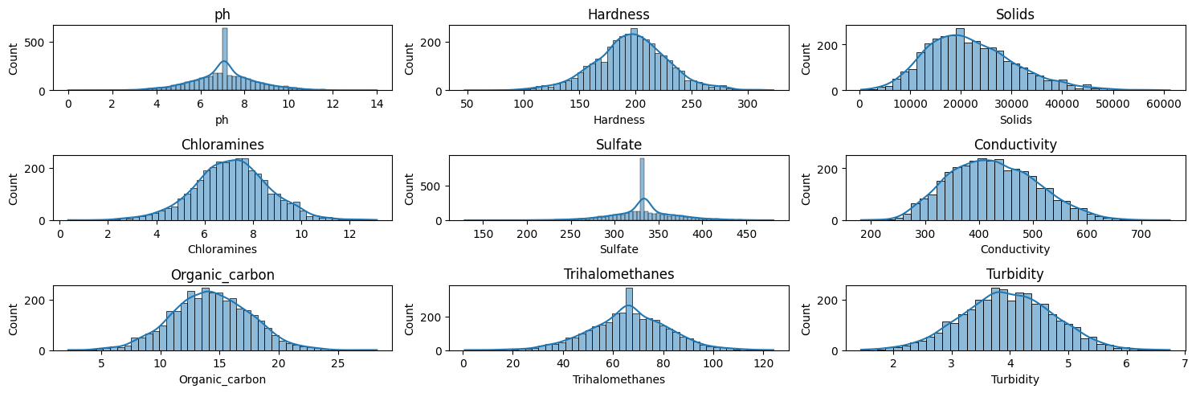

# 7.2.Boxplot

In [38]:

features_num = ['ph', 'Hardness', 'Solids', 'Chloramines', 'Sulfate',

'Conductivity', 'Organic_carbon', 'Trihalomethanes',

'Turbidity']

for f in features_num:

fig, (ax1, ax2) = plt.subplots(2, 1, figsize=(10,6), sharex=True)

ax1.hist(data[f], bins=30)

ax1.grid()

ax1.set_title(f)

*# for boxplot we need to remove the NaNs first*

feature_wo_nan = data[~np.isnan(data[f])][f]

ax2.boxplot(feature_wo_nan, vert=False)

ax2.grid()

ax2.set_title(f + ' - boxplot')

plt.show()

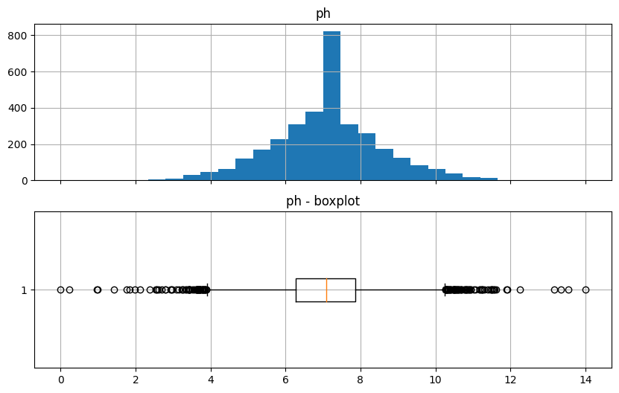

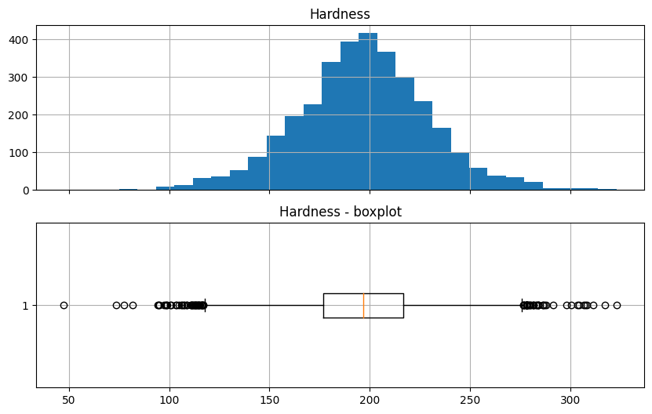

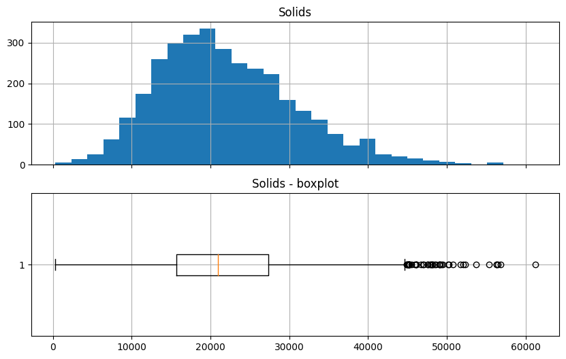

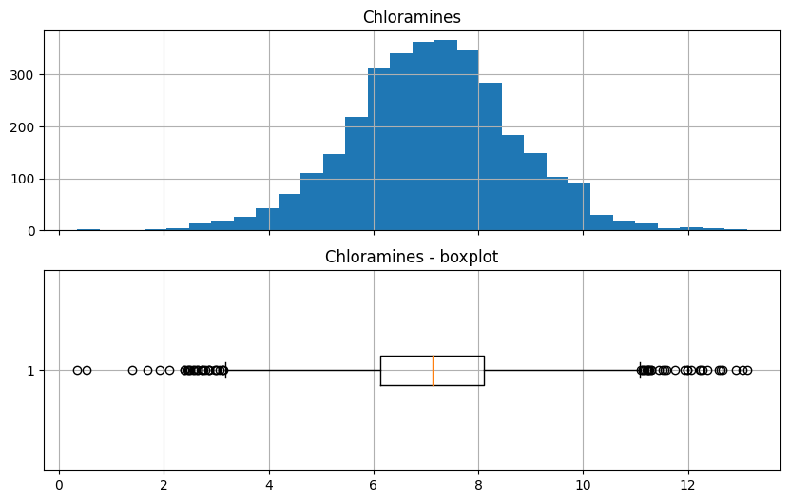

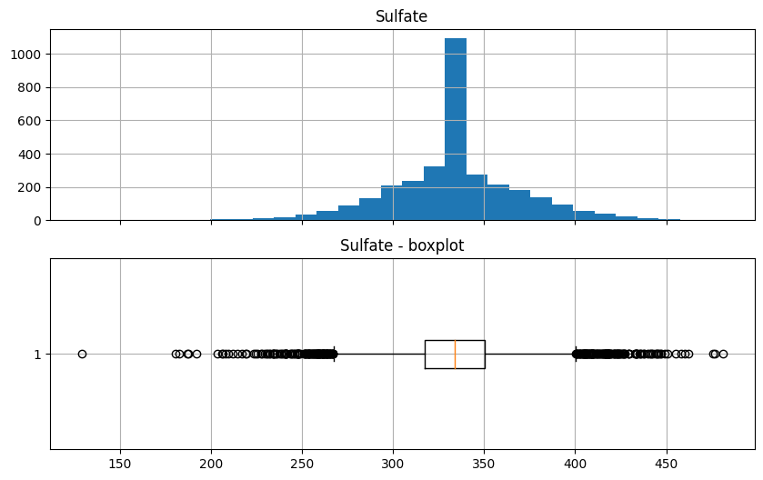

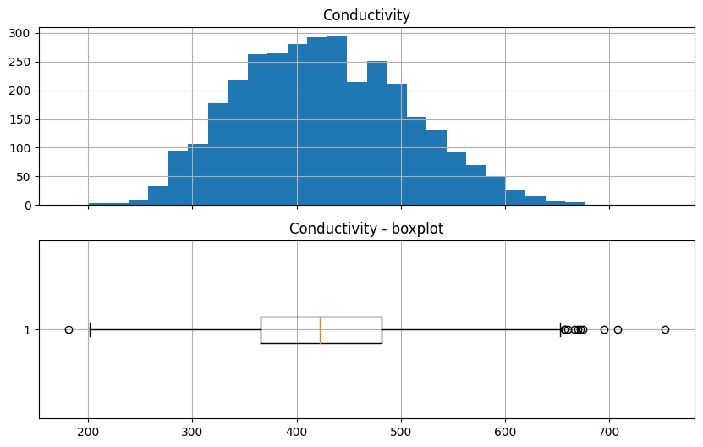

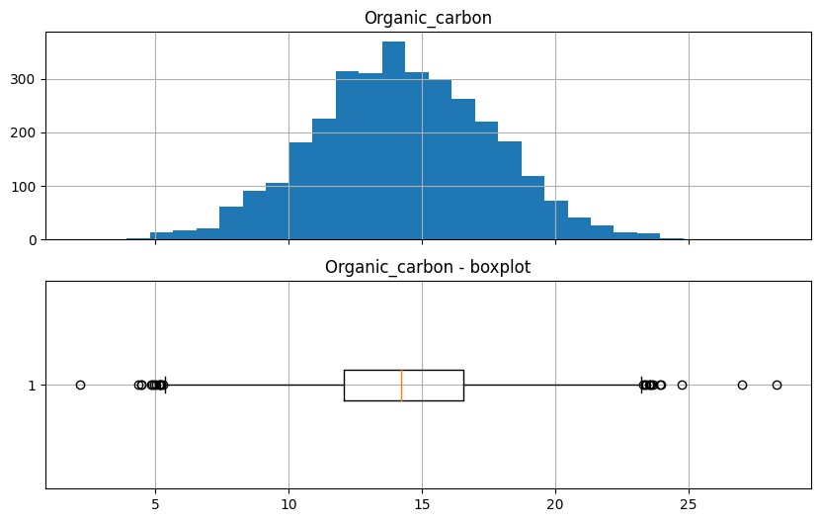

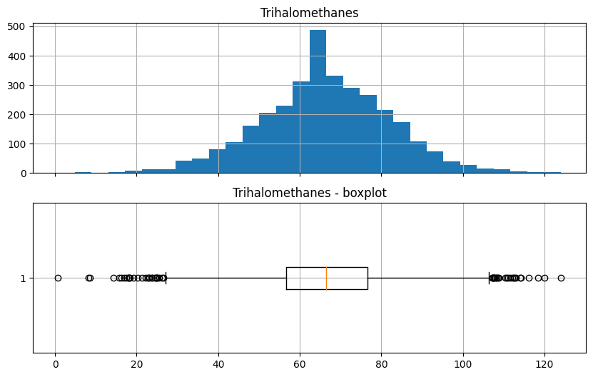

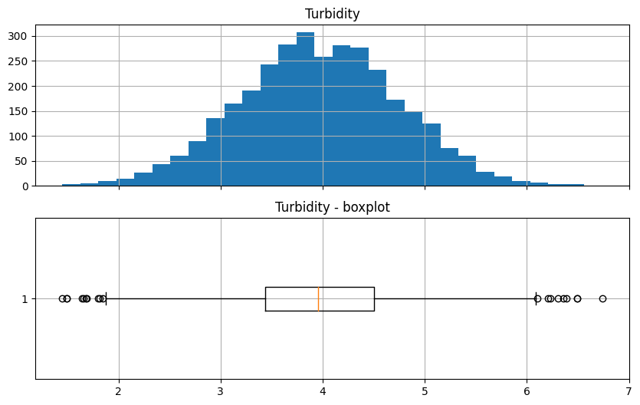

# 7.3.Scatter Plots.

In [39]:

sns.pairplot(data=data,hue="Potability")

Out[39]:

<seaborn.axisgrid.PairGrid at 0x7f615b2bff70>

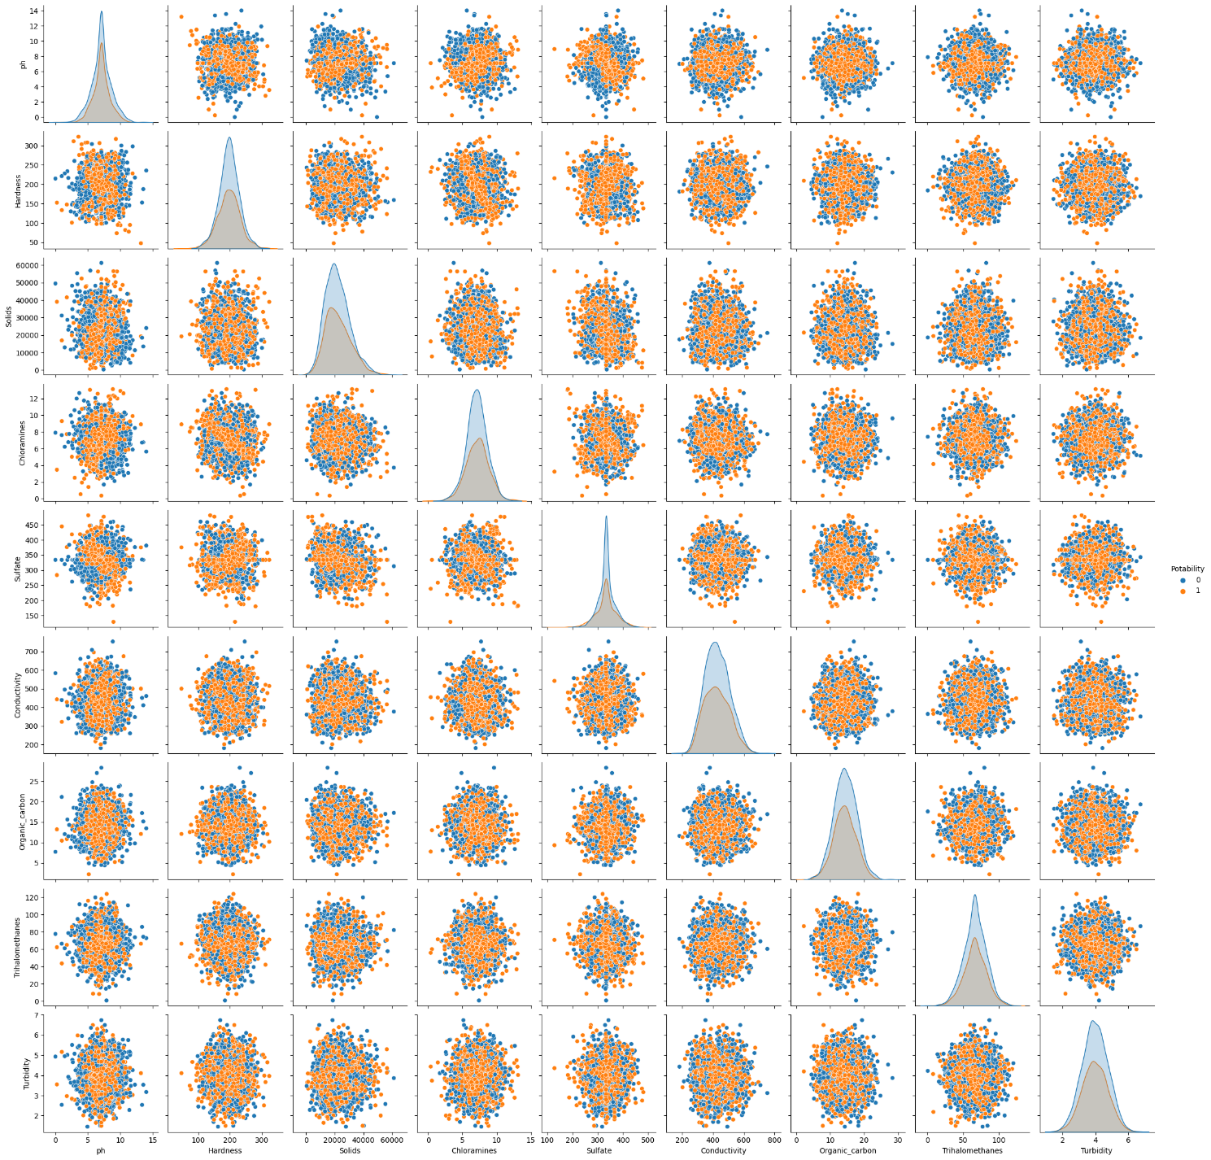

# 7.4.Correlation Heatmap.

In [41]:

corr_mat = data.corr()

fig, ax = plt.subplots(figsize=(15,10))

ax = sns.heatmap(corr_mat,annot=True,linewidths=0.5,fmt='.3f',cmap='YlGnBu')

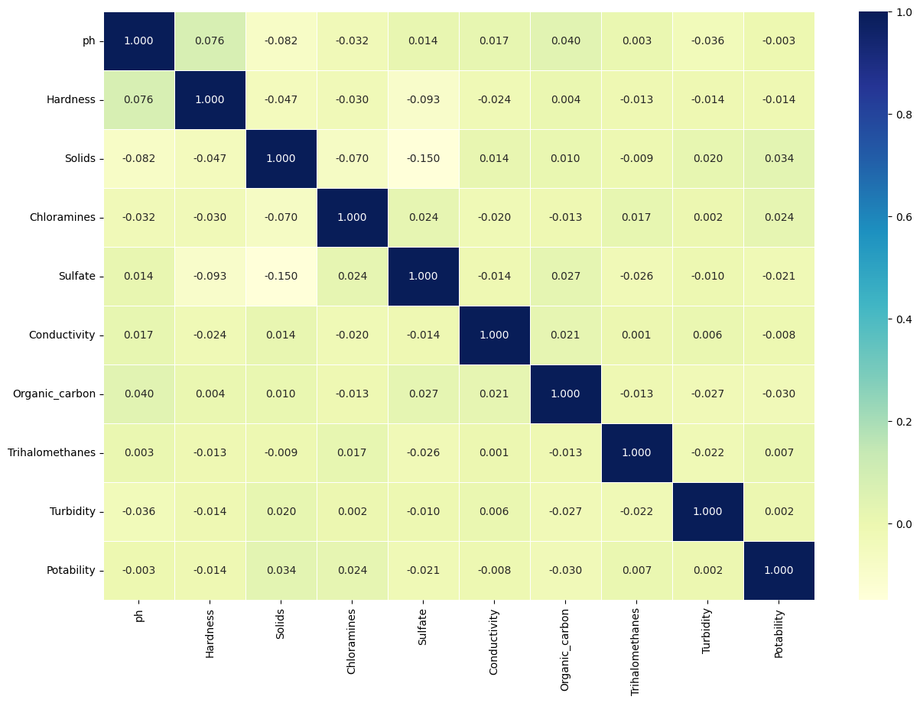

**8.Predictive Modelling for Potability**

* A Random Forest Classifier was selected as the predictive model due to its ability to handle complex relationships within the data.
* The model was trained on the pre-processed and balanced dataset.
* Hyperparameter tuning was performed using Grid Search CV to optimize the model's performance.
* The accuracy of the best-tuned model was approximately 68.7%.

# 8.1.Data Splitting.

In [43]:

from sklearn.preprocessing import Normalizer, StandardScaler

sm = SMOTE(random_state=42)

X, y = data[data.columns[:-1]], data["Potability"]

X, y = sm.fit_resample(X, y)

X_train, X_test, y_train, y_test = train_test_split(X, y, test_size = 0.25)

# 8.2.Predictive Model.

In [44]:

models = [RandomForestClassifier()]

pipelines = {}

for model in models:

model_name = str(model.__class__).split(".")[-1].split("'")[0]

pipe = Pipeline([

("scaler", StandardScaler()), *# Preprocessing step*

("classifier", model) *# Classifier step*

])

pipelines[model_name] = pipe

for name,pipe in pipelines.items():

print(f"Training {name}")

scores = cross_val_score(pipe, X_train, y_train, cv = 5, scoring = "accuracy")

print(f"Mean Score {scores.mean()} -- Std {scores.std()} -- Min {scores.min()} -- Max {scores.max()}")

pipe.fit(X_train, y_train)

Training RandomForestClassifier

Mean Score 0.6860133555926544 -- Std 0.02028633344384759 -- Min 0.654424040066778 -- Max 0.715

**8.3.Hyperparameter tuning the RandomForest model.**

In [45]:

param_grid = {

"criterion": ["gini", "entropy", "log_loss"],

'n_estimators': [10, 20, 30, 40,50],

'max_depth': [5, 10, 20, 30, 50],

}

rf_classifier = RandomForestClassifier(random_state = 42)

scorer = make_scorer(accuracy_score)

grid_search = GridSearchCV(

rf_classifier, param_grid, scoring=scorer, cv=5, verbose = 1

)

grid_search.fit(X_train, y_train)

best_rf = grid_search.best_estimator_

best_predictions = best_rf.predict(X_test)

best_accuracy = accuracy_score(best_predictions, y_test)

print("Best Accuracy Score:", best_accuracy)

Fitting 5 folds for each of 75 candidates, totalling 375 fits

Best Accuracy Score: 0.6766766766766766

**8.4.RandomForest model Accuracy Score.**

In [46]:

accuracy_score(best_rf.predict(X_test),y_test)

Out[46]:

0.6766766766766766

**8.5.Confusion Matrix**

In [47]:

plt.figure(figsize=(10,5))

sns.heatmap(confusion_matrix(best_rf.predict(X_test),y_test), annot = True,fmt='.1f')

plt.ylabel("Actual")

plt.xlabel("Predicted")

plt.title("Confusion Matrix")

plt.tight_layout()

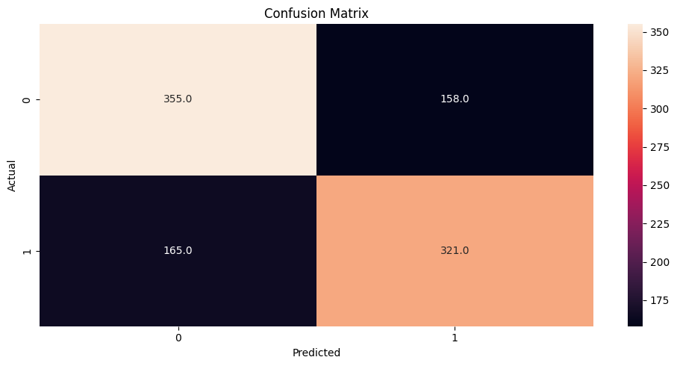

**9.Analysis Insights:**

* The analysis provides a comprehensive understanding of the various factors influencing water quality, such as pH, hardness, chloramines, and organic carbon. By visualizing the distribution and relationships between these parameters, water quality can be more effectively assessed.
* The developed Random Forest Classifier serves as a reliable tool to determine the potability of water samples. With an accuracy of around 68.7%, the model can assist in categorizing water samples as potable or non-potable, aiding regulatory bodies and water treatment facilities in decision-making processes.
* Through EDA and the correlation heatmap, it was observed that certain parameters, such as chloramines and sulfate, significantly influence water potability. These insights can guide further research and regulatory efforts, emphasizing the importance of monitoring and controlling these specific parameters.
* The analysis flagged outliers in various water quality features. Detecting these outliers is crucial for understanding abnormal patterns in water samples, potentially indicating contamination or issues in the water supply system.
* The analysis equips decision-makers with a data-driven approach to assess water quality. By leveraging the predictive model, authorities can make informed decisions regarding water treatment processes, ensuring the delivery of safe and potable water to the public.

**10.FINAL IBM COGNOS REPORT:**

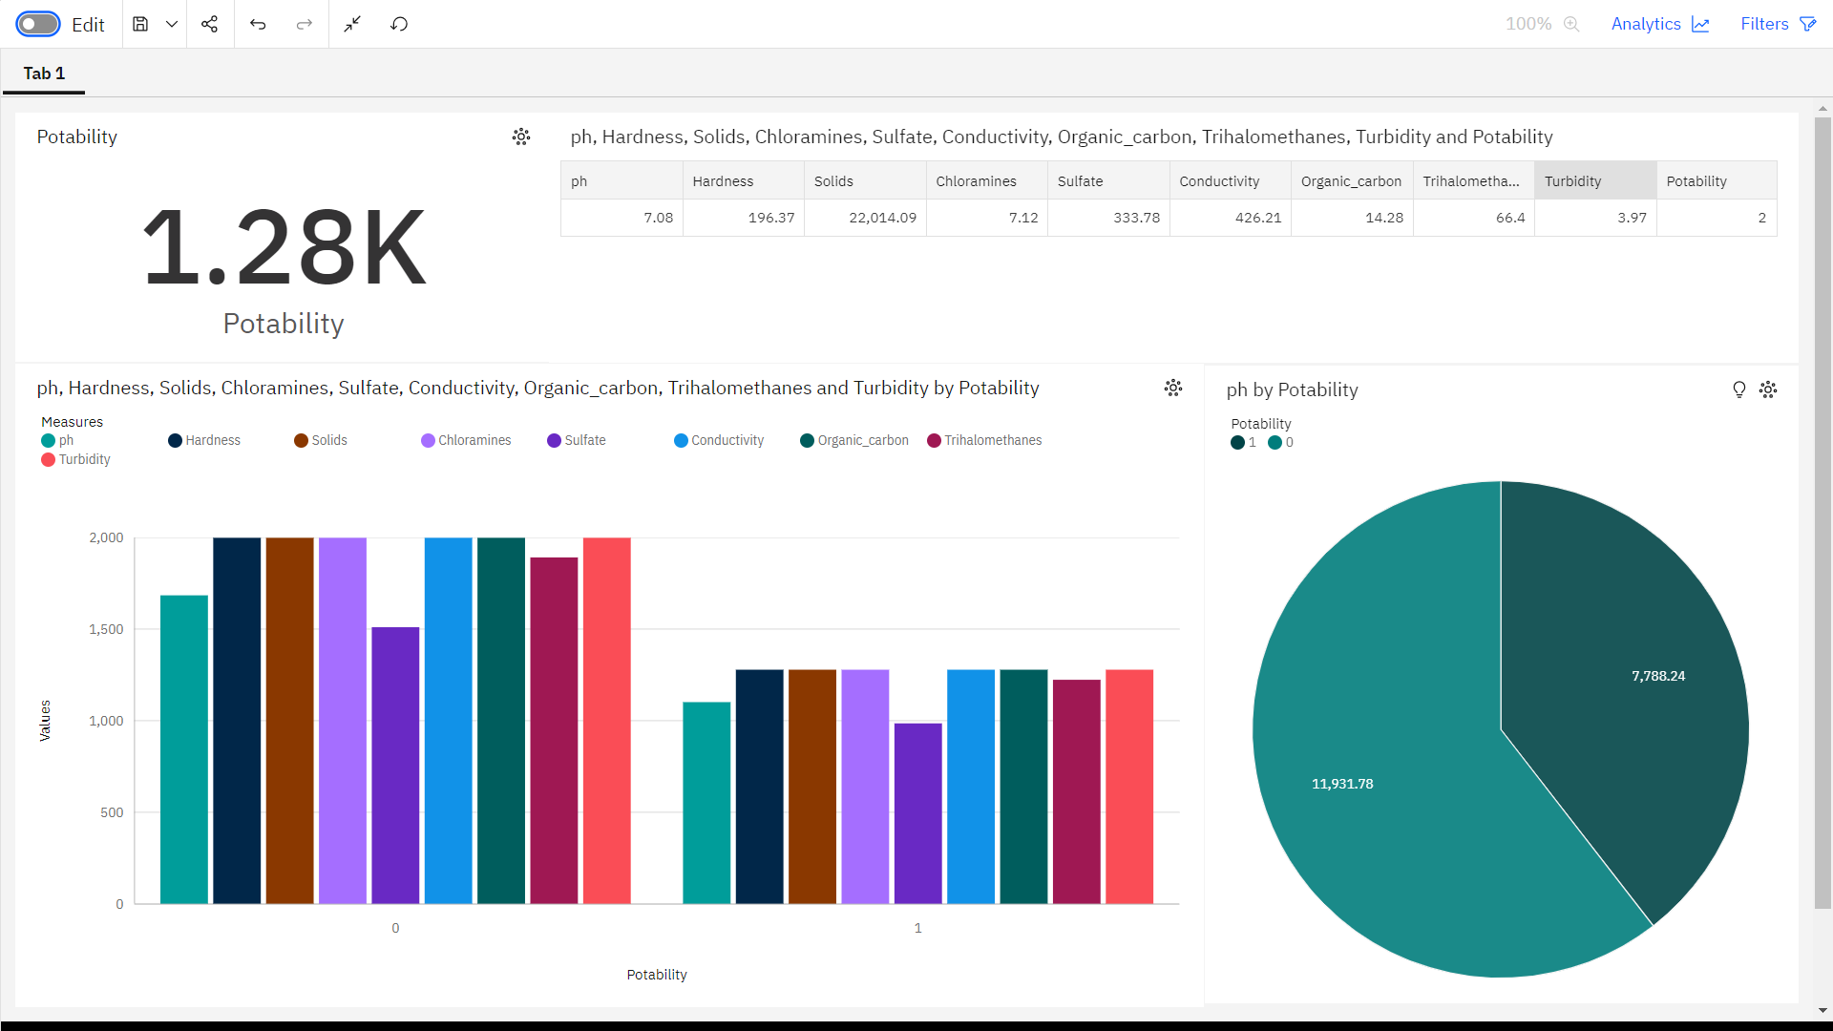

**11.Conclusion:**

In this project, we conducted an in-depth analysis of water quality data and built a predictive model to determine water potability. The dataset contained various features related to water quality, such as pH, hardness, solids, chloramines, sulfate, conductivity, organic carbon, trihalomethanes, and turbidity. We began by handling missing values, filling them with the mean of respective columns. Exploratory data analysis (EDA) involved visualizations like histograms, boxplots, scatter plots, and correlation heatmaps, giving us insights into feature distributions and relationships.

To address class imbalance, we employed the SMOTE technique, creating a balanced dataset. We then trained a Random Forest Classifier and performed hyperparameter tuning using Grid Search. The best model achieved an accuracy of approximately 67.7% on the test data.

In summary, the analysis underscores the complexity of water quality dynamics. While the predictive model provides a reasonable accuracy, further exploration could involve more advanced techniques, additional features, or domain-specific knowledge integration for improved predictions. Additionally, ongoing data collection and refinement of models will be vital for enhancing the accuracy and reliability of water potability predictions, crucial for both public health and environmental sustainability.